**Project Name : r Creators**

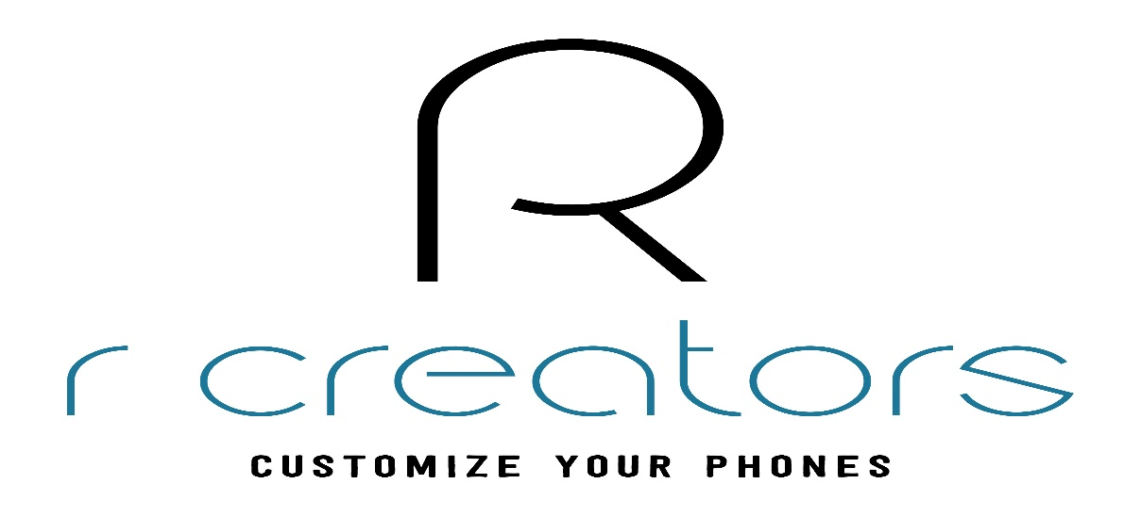

OVERVIEW:

It’s an e-commerce website for selling mobile accessories and electronic devices like air buds, neckbands, and trending mobile back cover, digital watches at reasonable price and best quality. Also providing mobile and other electronic devices skin like laptop skins , watch skin, keyboard skin available online.

1. Login Page:
   * + - Login
       - Sign Up
2. Home Page:
   * + - Company Logo
       - Social media links
       - Search bar
       - Filters
       - Product Images with their description
       - Footer contain Contact Details, Location, About Us.
3. Payment Page:
   * + - Address section for delivery.
       - Payment options g pay, phone pay, UPI, Net Banking, BHIM UPI, Debit Card, Credit Card.
4. Software Required:

Front-End:

* + - * Html
      * CSS
      * Bootstrap
      * React

Dynamic:

* + - * Java Script
      * Ci/cd with AWS
      * Login and Logout (oath and jwt)

Database:

* + - * Mongo dB
      * Json Data

Code Compilers:

* + - * Visual studio code
      * Git bash
      * Git hub
      * Node js.